Sailing yacht Liberty (1921?)

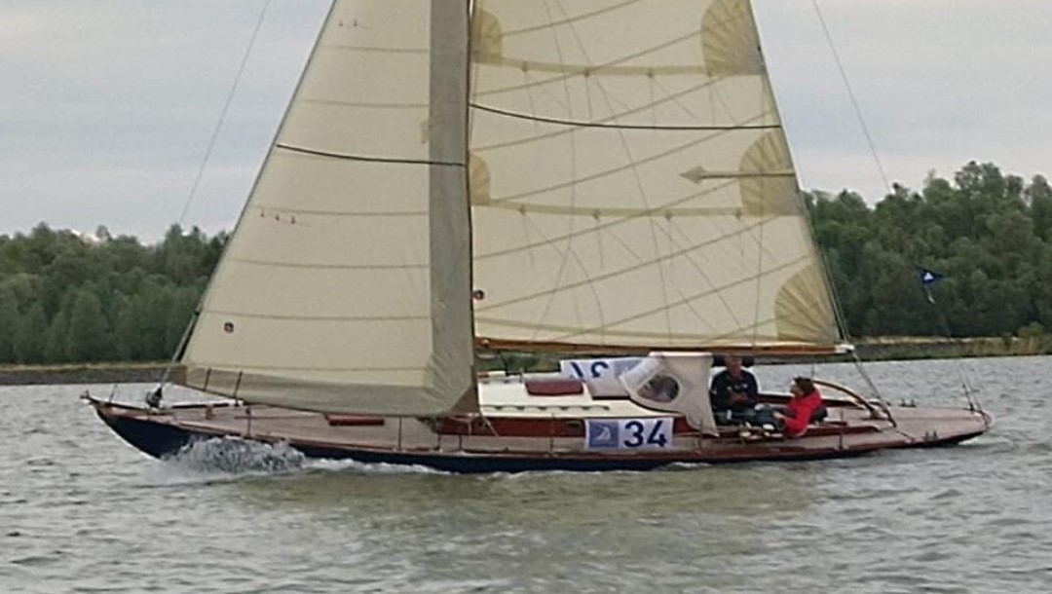

History off Liberty as far as we know it today.
My dad bought Liberty in 1974 in a small town called Rozenburg near Rotterdam in the Netherlands. She was owned by an Englishman listening to the name Mister Martin. Liberty stood in a yard, next to a small firm known as Gordini, which we think was owned by mr Martin. She stood there after being sunk at lake IJsselmeer. She sunk due to a gibe going wrong. The date of the gibe going wrong we do not know. The day after my dad bought Liberty all the bronze fittings were stolen, winches, portholes and most important the plaque of the builder/designer. The only info left was what mr Martin has told my dad and that is the following. Liberty was built in 1921 in America and Liberty is still her original name.
Besides that we had contact with a R-class association in the US. Liberty, with her dimensions, could be a R-class boat. She is however on the small side for that and there is another detail that doesn’t fit a R-class. Liberty has a deckstep mast in stead of a keelstep mast.

General data

Subject | Metric | Imperial
Lenght (oa) | 10,70 mtr | 35,1 ft
Length (wl) | 7,60 mtr | 24,9 ft
Width | 2,30 mtr | 7,54 ft
Draft | 1,75 mtr | 5,74 ft
Weight | 5750 kg | 12676,6 lb
Sail area | 49,7 m2 | 535 ft2
Length mast | 12,99 mtr | 42,6 ft
Length boom | 4,90 mtr | 16,1 ft

Below some pictures and more explanation on details which could help identify Liberty.

Bow:
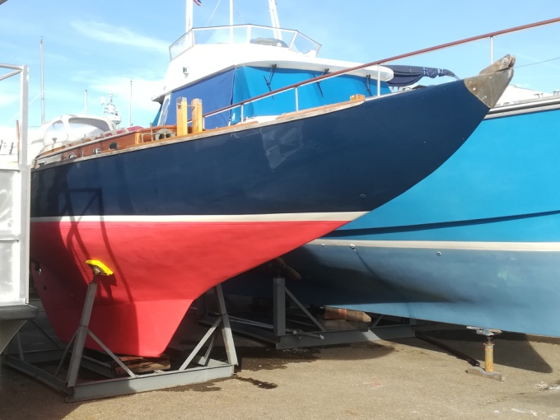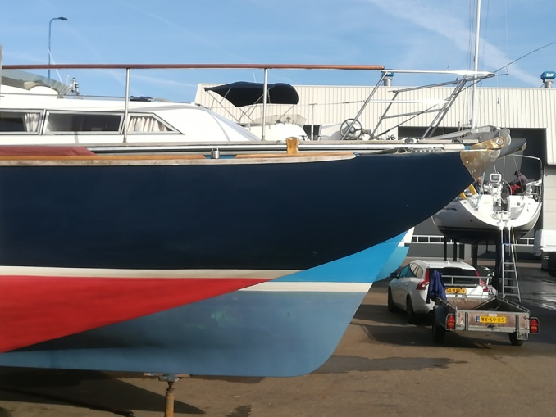

From the waterline up her bow makes a slight curve upwards.

Stern:

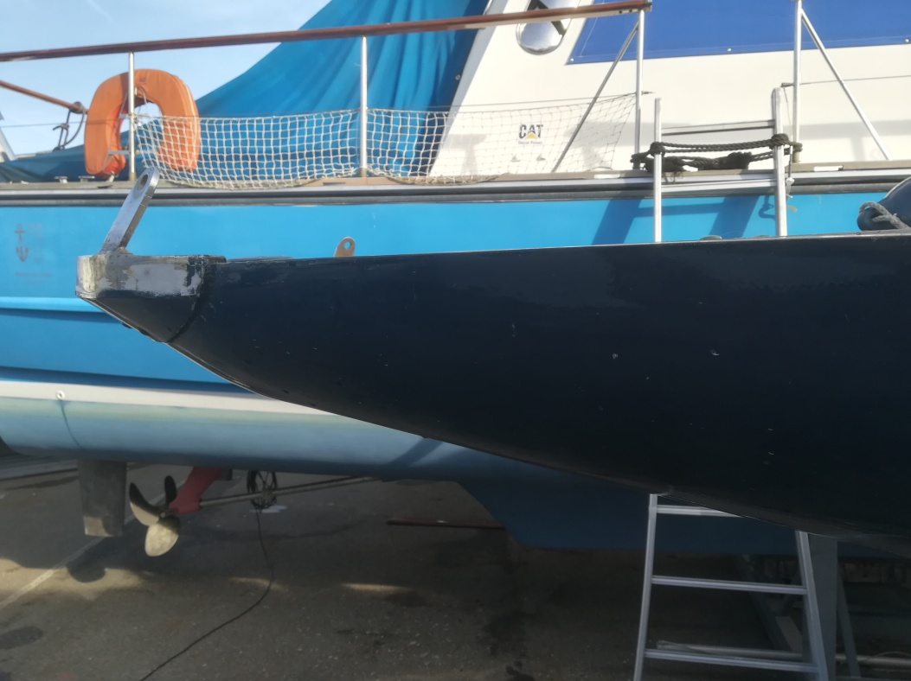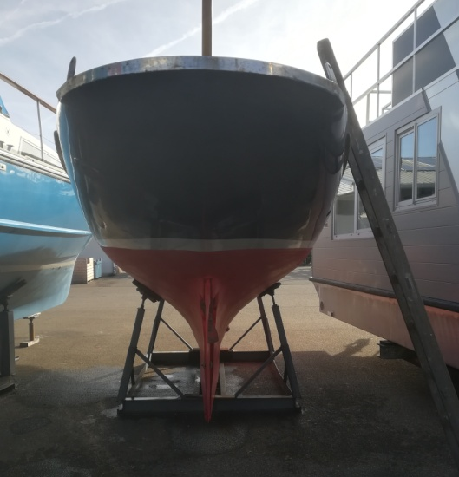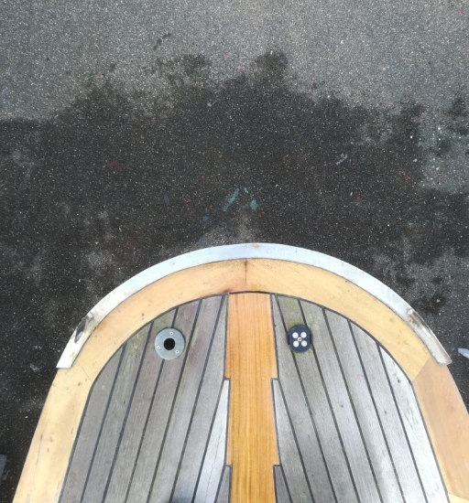

Her stern is round and when you look at the stern from the side there is a little nod just below the deckline.

Keel:
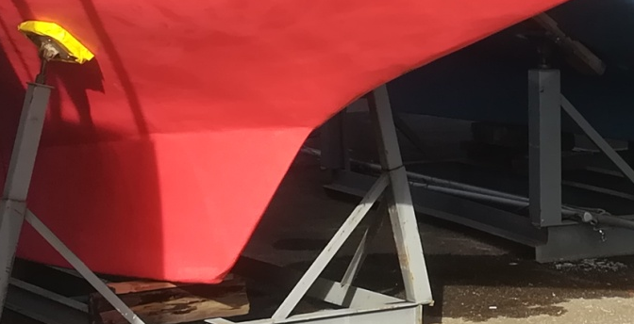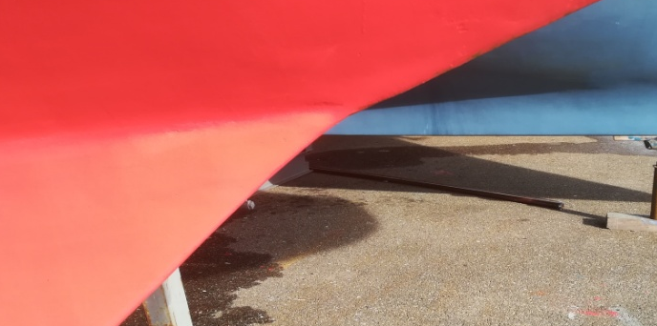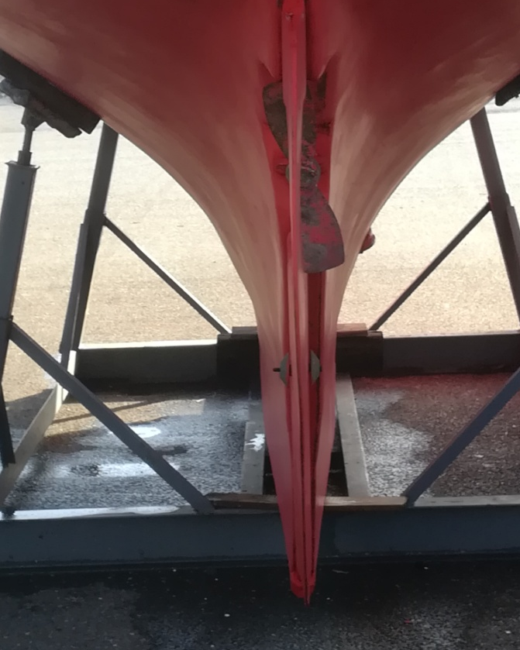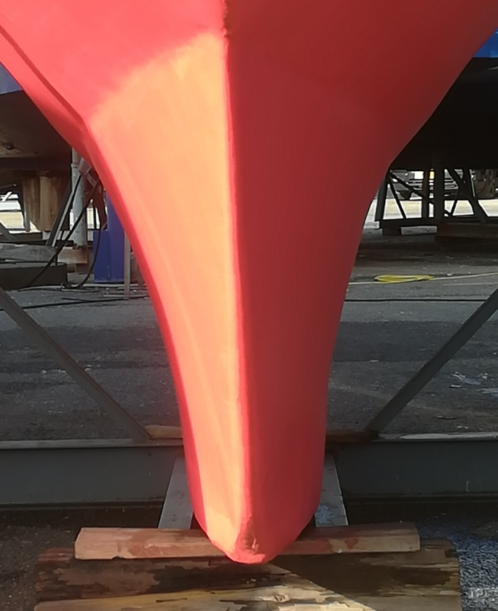

Her keel makes a very little nod where the wooden hull is going over in the cast iron ballast. The bow however makes a small curve to fit the lines of the ballast.

Ballast:
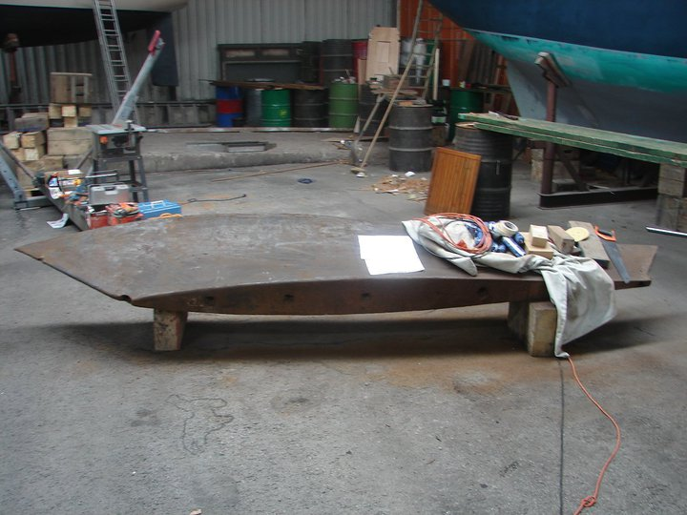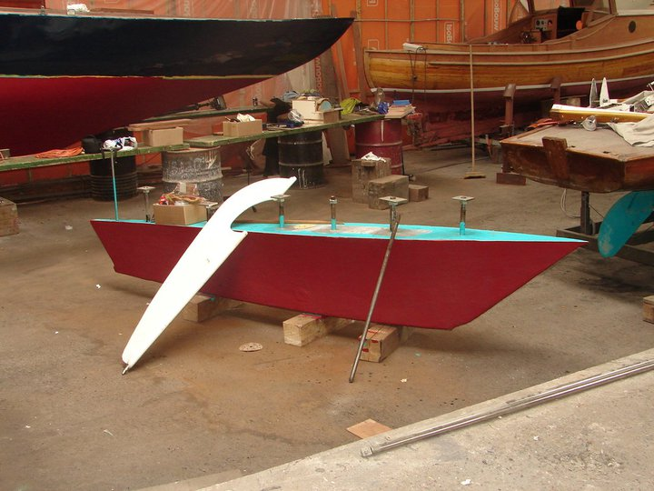

Liberty's ballast is made of cast iron . The ballast is casted in the shape of the hull, this is a detail we have not seen on many other classic yachts so far.

Construction details:
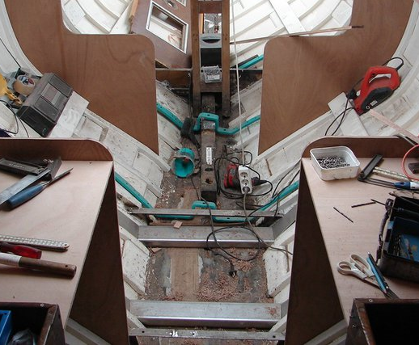

Liberty has a separate beam for her bow and stern and in the middle there is a oak plate of approx 10 cm (0,33 ft) thick. The bow beam was fixed to the "keel plate" with forged iron frames, a few of them are still in place (the green frames in the picture). The ballast was also "hanging" in such frames but the most damaged ones we replaced with stainless steel new ones.

Rig:
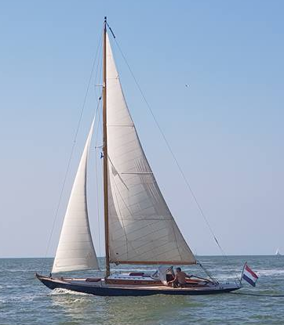

Liberty has a deck step mast and a sloop rig. There is one detail which is not seen that often and that is the following. The main spreaders on her mast are slightly wider than the hull.
Her mast and boom are made of pine, are square shaped and hollow.

Hull:
the hull is made of oak and pine over oak frames. Below the waterline she has oak planking and above the waterline pine planking. The frames are made of oak are approx 1 inch x 1 inch in diameter and are placed every 25 cm (0,8 ft) approx. The planking above the waterline is thinner (19 mm/0,75 inch) than the planking below the waterline(25mm/ 1 inch). In the cabin and in the rear, where she now has an engine, there were two rings to hoist her out of the water. These rings were the nuts on two of her keel bolts.



